UNIT 2
Lesson 5 - I live at school

1 Some pupils live on the school grounds.
Neki učenici žive u školi koju pohađaju.
This is called boarding school.
Takve škole nazivaju se internatima.
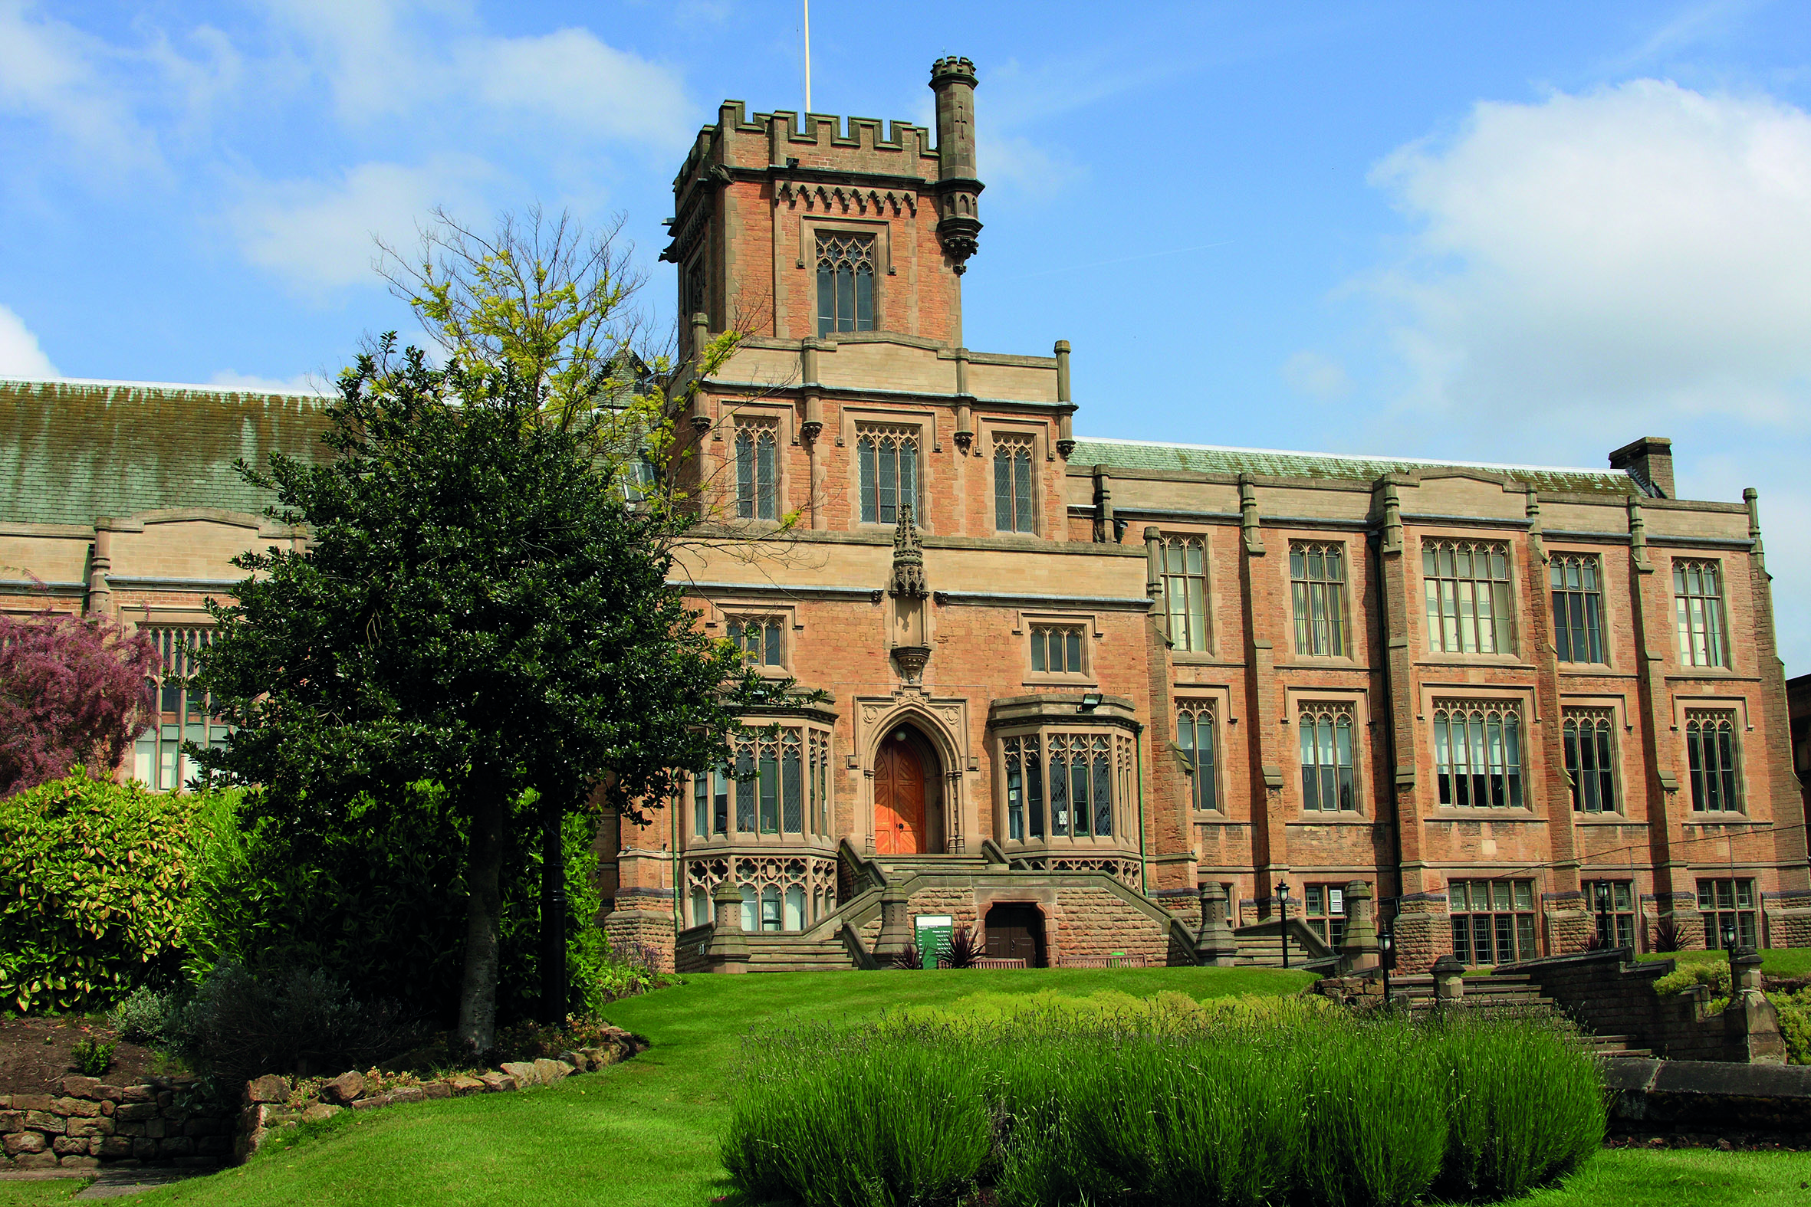
Would you like to live in a boarding school? YES NO
Je li bi volio živjeti u internatu?
Why would / wouldn't you like to live in school?
Talk to your friend.
Zašto bi ili ne bi volio živjeti u školskom internatu?
Porazgovaraj s prijateljem.

2 Harry lives in a boarding school.
Harry živi u internatu.
a) First read the text and find out what Harry likes
or doesn't like about it.
Pročitaj tekst i saznaj što Harry voli / ne voli.
b) Read the text again and find the right headings.
Pročitaj tekst još jednom i daj naslove dijelovima teksta.
Look for the underlined words to help you.
Potraži podcrtane riječi koje će ti pomoći riješiti zadatak.
MY SCHOOL (moja škola)
OUR HOUSE (naša kuća)
THE ROOMS WE SHARE (zajedničke sobe)
MY ROOM (moja soba)

_________MY SCHOOL (moja škola)_________
Heading A
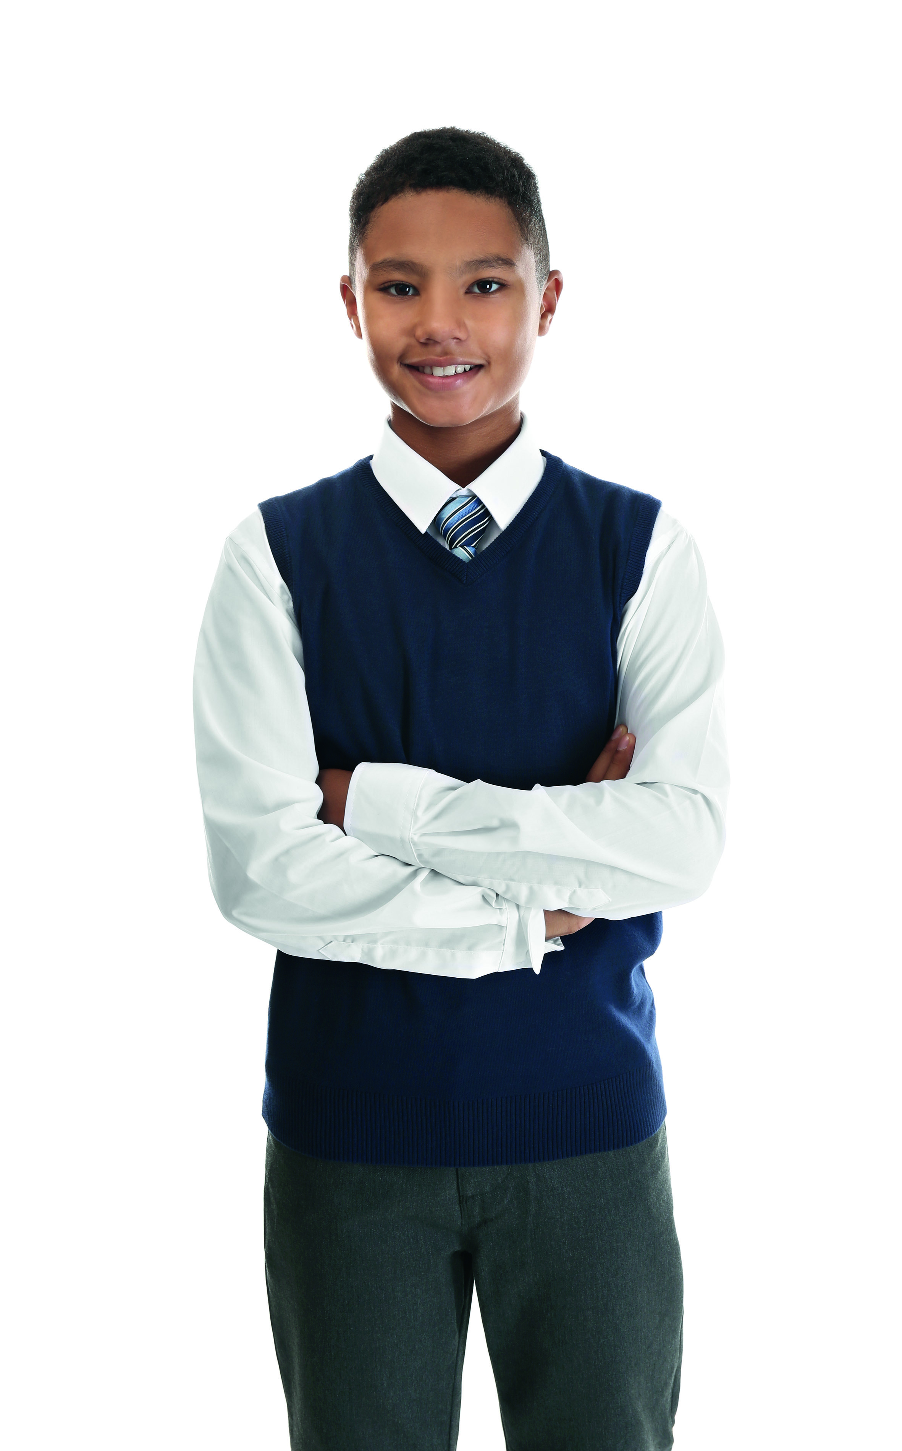
Naslov A

Hello! My name's Harry.
Bok! Moje ime je Harry.
I'm eleven (11).
Imam 11 godina.
I go to boarding school in England 
Idem u internat u Engleskoj.

____________________________________________
Heading B
Naslov B
I live with my schoolmates and four (4) teachers.
Živim sa svojim prijateljima iz razreda i četiri učitelja.
We live in a house near the school.
Mi živimo u kući blizu škole.
I live in all-boys boarding house.
Živim u kući za dječake.
There are girls in our school.
Djevojčice idu s nama u školu.
There are many rooms 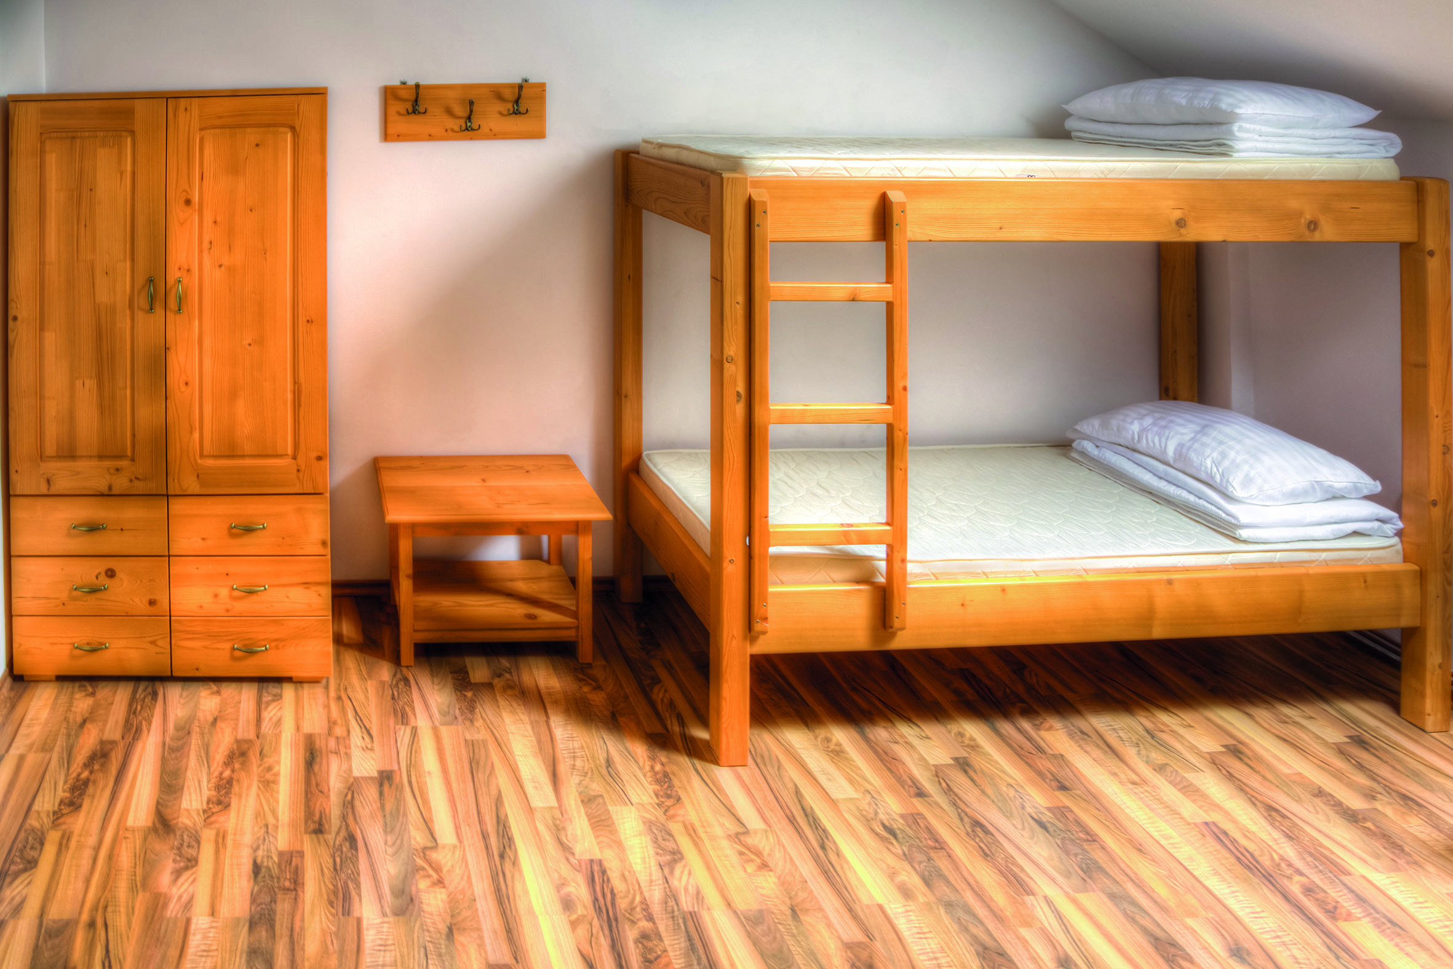 in the house.
U kući ima puno soba.
There are three (3) or two (2) boys in each room.
U svakoj sobi smješteno je po tri ili dva dječaka.

____________________________________________
Heading C
Naslov C

In my room there is a bunk bed 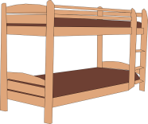
U mojoj sobi se nalazi krevet na kat
and two big wardrobes. 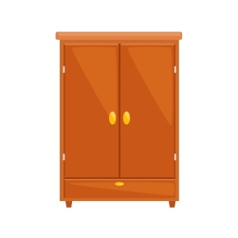
i dva velika ormara.
There are two (2) desks 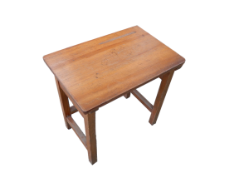
Tamo su i dva radna stola

and two (2) bookshelves. . My roomate is Liu.
i dvije police za knjige. Liu je moj cimer.

He is from China. 
On je iz Kine.
Sometimes we do our homework in our room.
Ponekad pišemo zadaću u svojoj sobi.
Mostly we do our homework in a common room.
Uglavnom pišemo zadaću u dnevnoj sobi (zajedničkoj sobi).
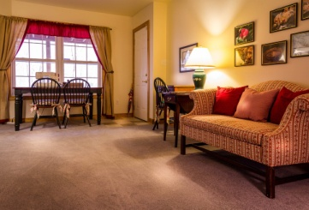

____________________________________________
Heading D
Naslov D

There are two (2) kitchens.
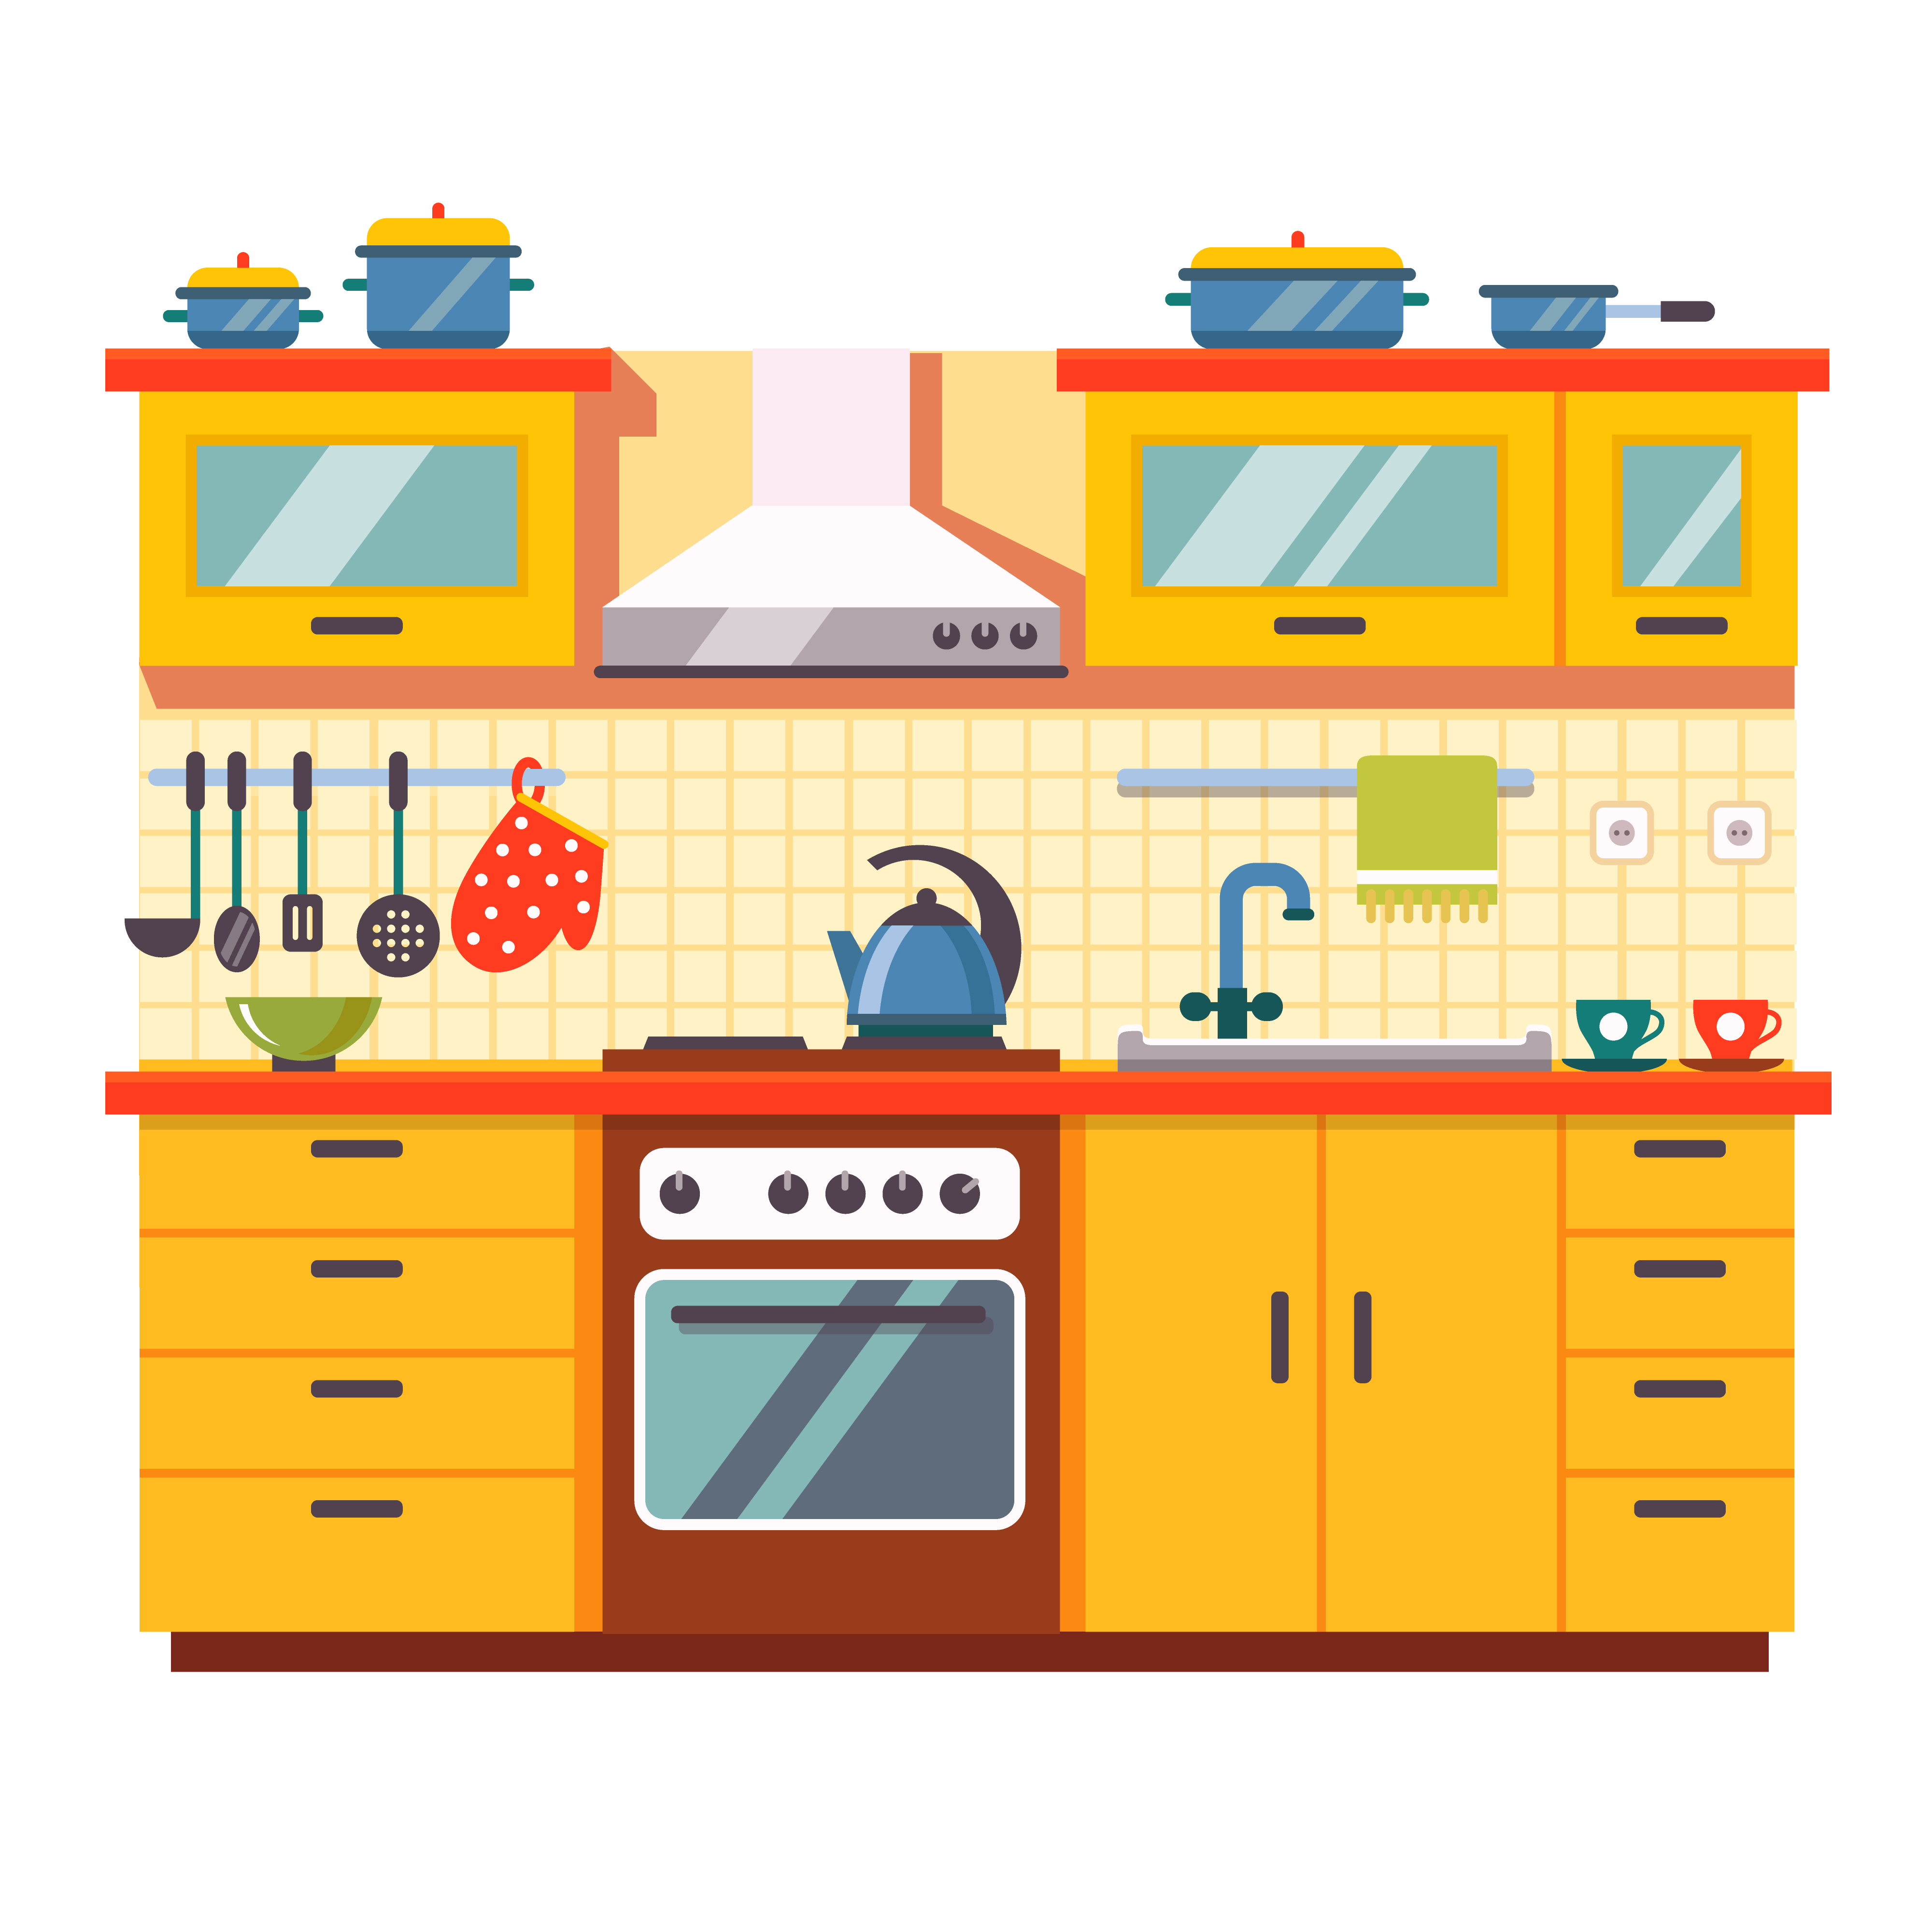
U kući su dvije kuhinje.
We tidy them up.
Sami ih čistimo.

There are four big bathrooms
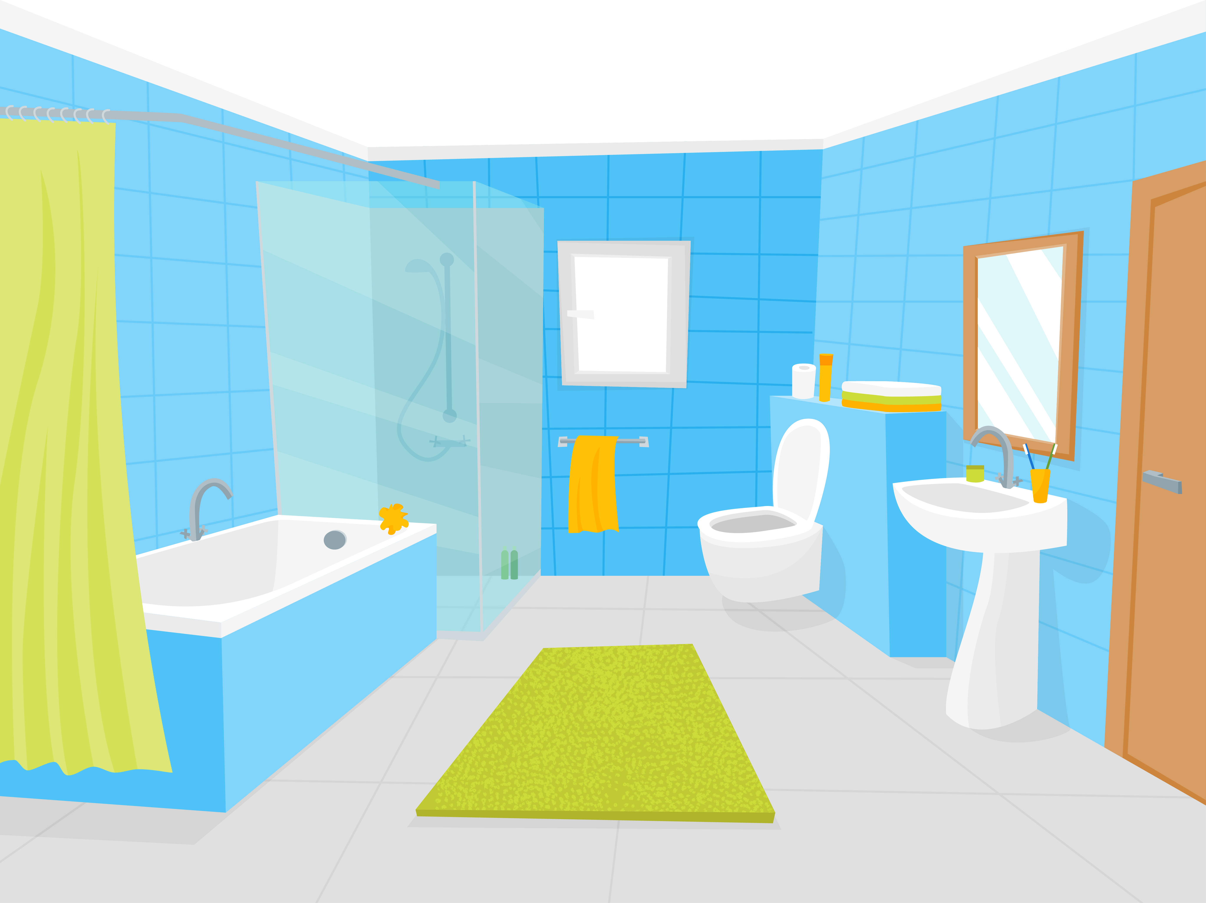
Tamo su četiri velike kupaone

with lots of showers and washbasins. 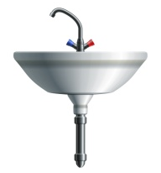
s puno tuševa i umivaonika.
Living with my friends is fun.
Život s prijateljima je zabavan.

But it can be tricky sometimes because we have to study, too.
Ali ponekad to može biti nezgodno jer trebamo i učiti.

- 3 Read the text in task 2 once again.
Pročitaj tekst u zadatku 2 još jednom.
Mark the true sentences with a tick .
Označi točne rečenice kvačicom.
Mark the false sentences with a cross X .
Označi netočne rečenice križićem.


1 Harry goes to boarding school.
Harry ide u internat.

2 He lives with his schoolmates.
Živi sa svojim prijateljima iz škole.

3 Harry lives with teachers, too.
Harry živi i s učiteljima.

4 There are girls in his boarding house.
U internatu su i djevojčice.

5 There are many rooms in the house.
U kući je puno soba.

6 There are four (4) boys in each room.
U svakoj sobi smješteno je po četiri dječaka.

7 In Harry's room there is a bunk bed.
U Harryjevoj sobi se nalazi krevet na kat.

8 There are two (2) small wardrobes in his room.
U njegovoj sobi su i dva mala ormara.

9 There aren't desks or bookshelves.
Tamo nema stolova niti polica za knjige.

10 Harry's roomate is Liu.
Liu je Harryjev cimer.

11 He is from Croatia.
On je iz Hrvatske.
12 Harry often does his homework in a common room.

Harry često piše zadaću u dnevnoj sobi.
13 There is one (1) kitchen in the house.

U kući je jedna kuhinja.
14 Pupils tidy up the kitchen.

Učenici sami pospremaju kuhinju.

15 There is one (1) small bathroom in the house.
U kući je jedna malena kupaona.

16 Harry thinks that living with his friends is fun.
Harry misli da je život s prijateljima je zabavan.

Culture corner
BOARDING SCHOOLS

- 1 Read more about boarding schools.
Pročitaj još jedan tekst o internatu.

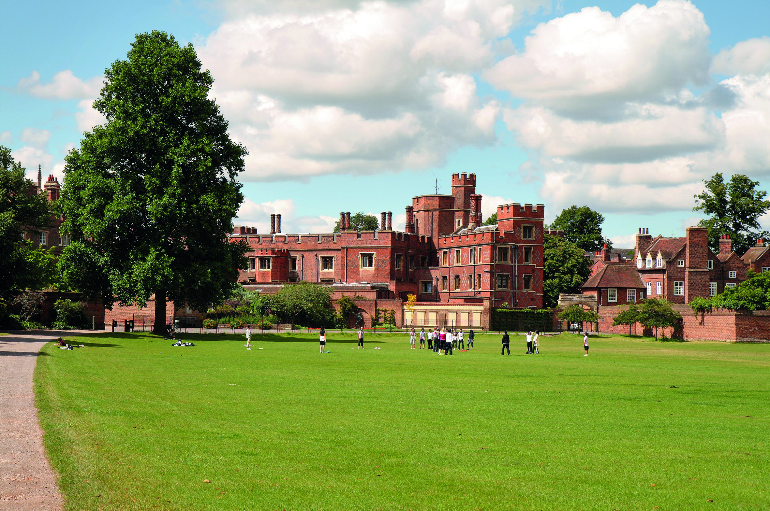
Eton College in the UK is one of the most famous
boarding schools.
Eton College u Ujedinjenom Kraljevstvu je jedan od najpoznatijih internata.

Princes William and Harry went to Eton.
Prinčevi William i Harry su pohađali Eton.

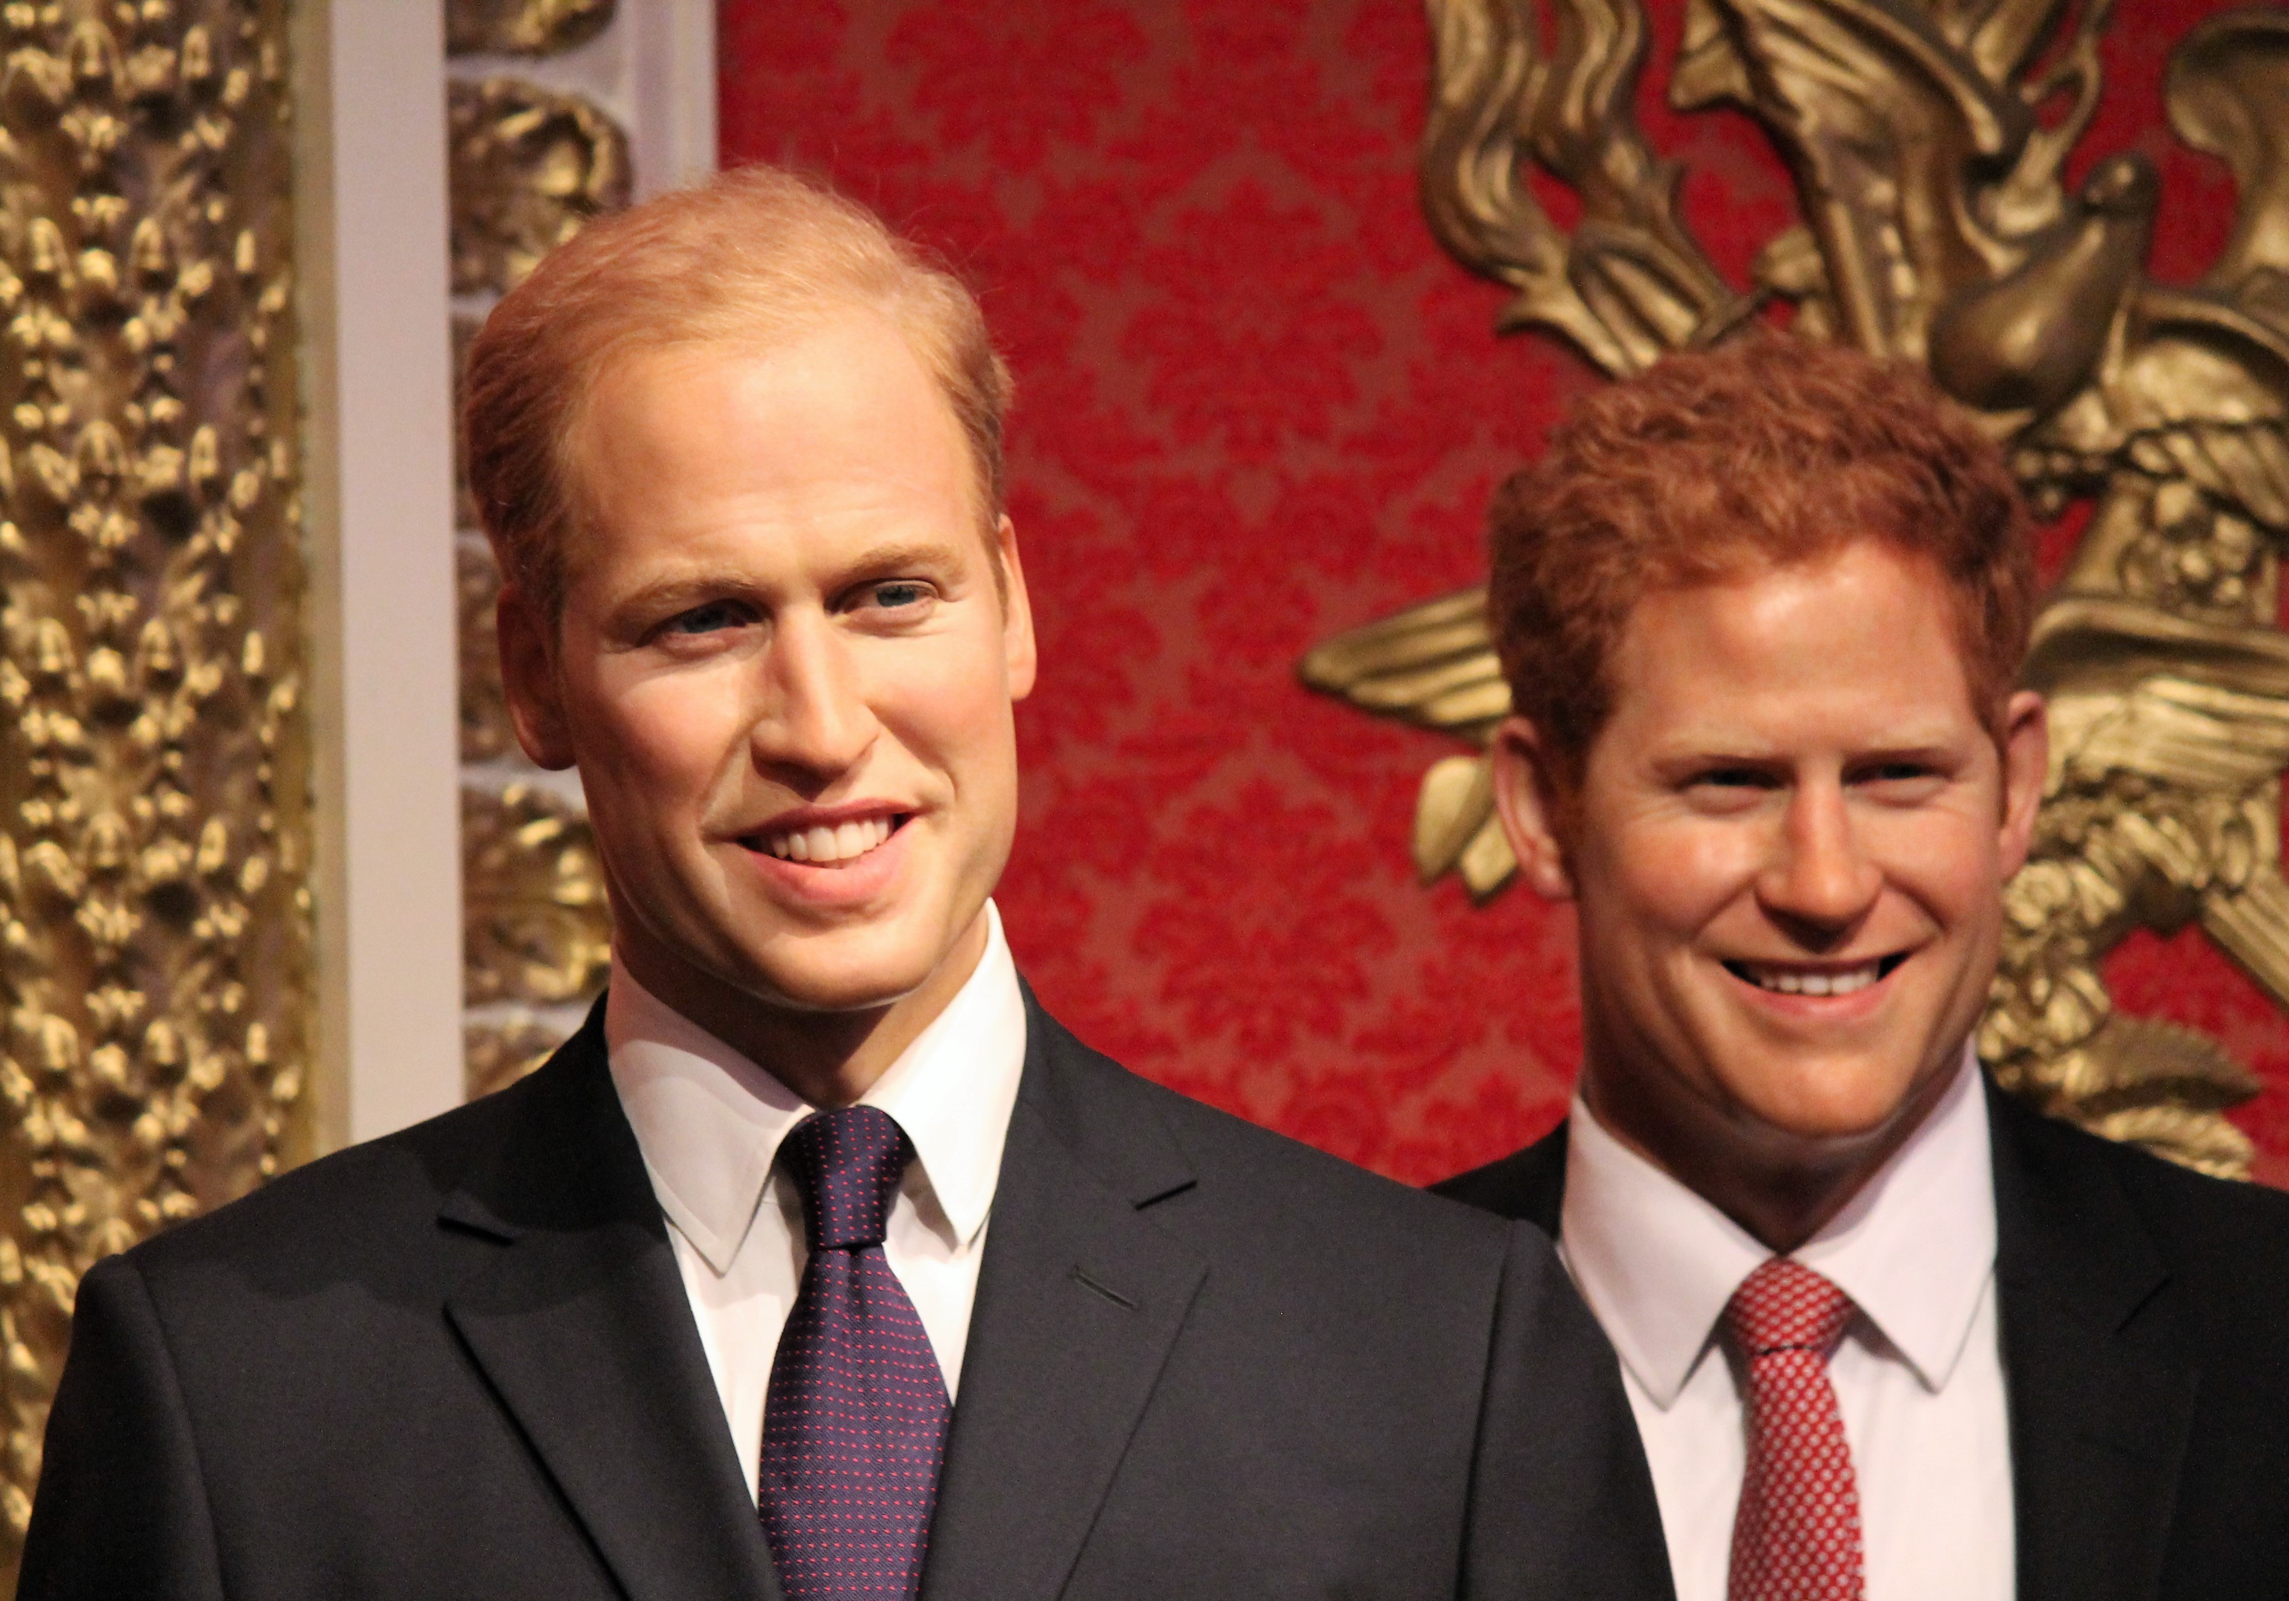

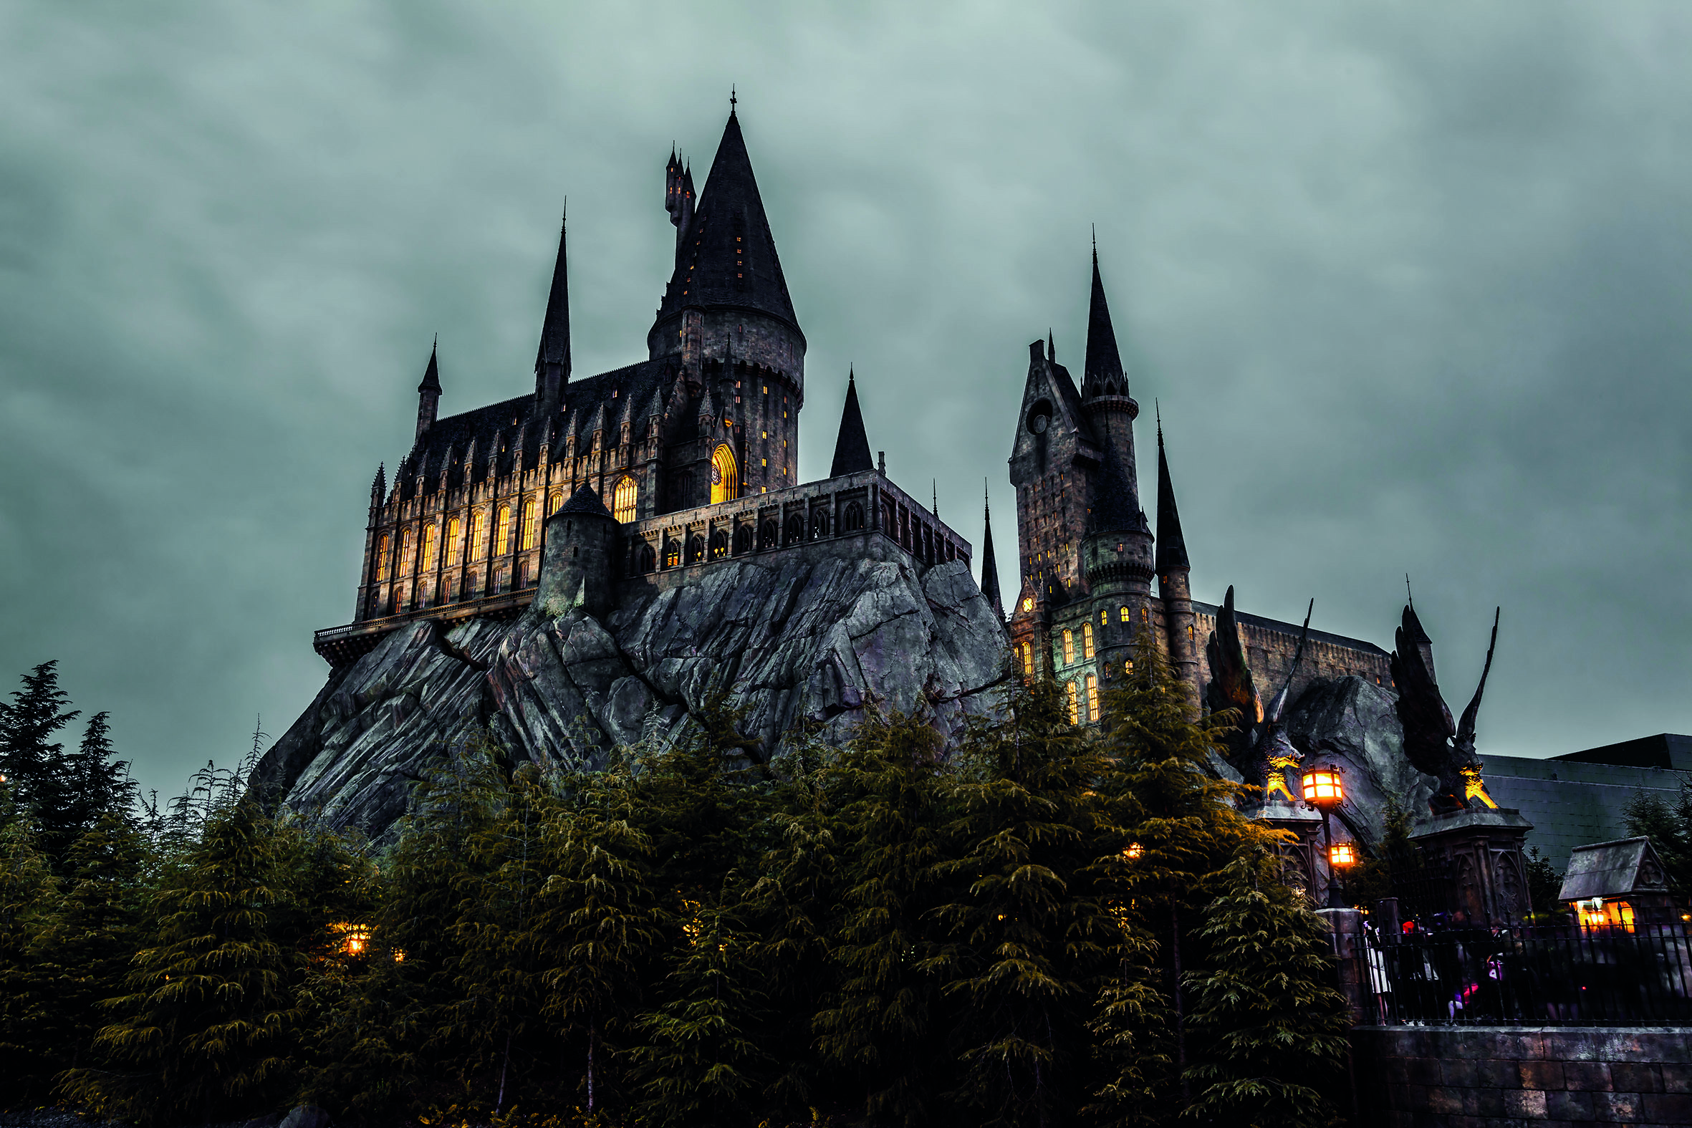
Harry Potter's Hogwarts School is also a boarding school.
Škola Harry Pottera - Hogwarts School je također internat.

- 2 What do you think about boarding school?
Što ti misliš o internatu?
What is good about boarding school?
Koje su dobre strane odlaska u internat?
What is bad about boarding school?
Koje su loše strane odlaska u internat?

a) Read the sentences.
Pročitaj rečenice.

You live in school.
Živiš u školi.
You live with your teachers.
Živiš s učiteljima.
Living with friends is fun.
Život s prijateljima je zabavan.
It is hard to study with your friedns around.
Teško je učiti kada su ti prijatelji u blizini.
There are only boys or only girls in a boarding house.
U internatu su samo dječaci ili samo djevojčice.
You share a room with your friends.
Dijeliš sobu sa svojim prijateljima.
You have a bunk bed.
Imaš krevet na kat.
You can cook in a boarding house.
U internatu možeš kuhati.
You go home for holidays.
Za vrijeme praznika ideš kući.

b) Sort out the sentences into two categories.
Organiziraj rečenice u svije skupine.

Advantages (good things)
Prednosti
___________________________________________________________________________________________________________________________________________________________________________________________________________________________________________________________________________________________________________________________________________________________________________________________________________________________________________
_____________________________________________________________

Disadvantages (bad things)
Nedostaci
___________________________________________________________________________________________________________________________________________________________________________________________________________________________________________________________________________________________________________________________________________________________________________________________________________________________________________
_____________________________________________________________

